**WIREFRAME DOCUMENT**

MUSHROOM CLASSIFICATION

Revision No – 1.1

Last Date of Revision – 12/09/2022

Author: Akshay Pandurang Paunikar

**Document Version Control:**

|  |  |  |
| --- | --- | --- |
| **Date Issued** | **Version** | **Description** |
| 11/09/2022 | 1 | Web Interface |
| 12/09/2022 | 1.1 | Sample Cases |

**CONTENTS**

|  |  |  |
| --- | --- | --- |
| **Sr. No.** | **Description** | **Page No.** |
|  | Document Version Control | 2 |
|  | Abstract | 4 |
| 1 | Web Interface | 5 |
| 1.1 | Home Page | 5 |
| 1.2 | How to use? | 6 |
| 1.3 | Results Page | 7 |
| 2 | Sample Cases | 8 |
| 2.1 | Poisonous Mushroom Example | 8 |
| 2.2 | Edible Mushroom Example | 9 |

**Abstract**

Mushrooms have been consumed since earliest history. The word Mushroom is derived from the French word for Fungi and Mold. Now-a-days, Mushroom are popular valuable food because they are low in calories, carbohydrate, Fat, sodium and also cholesterol free. Besides this, Mushroom provides important nutrients, including selenium, potassium, riboflavin, niacin, Vitamin D, proteins and fiber. All together with a long history as food source. Mushroom are important for their healing capacity and properties in traditional medicine. It has reported beneficial effects for health and treatment of some disease. Many nutraceutical properties are described in Mushroom like cancer and antitumor attributes. Mushroom act as antibacterial, immune system enhancer and cholesterol lowering Agent. Additionally, they are important source of bio-active compounds. This work is a machine learning model that classifies mushrooms into 2 classes: Poisonous and Edible depending on the features of the mushroom. During this machine learning implementation, we are going to see which features are important to predict whether a mushroom is poisonous or edible.

**1. Web Interface**

**App Link:** [**https://mushroom-classification-ml-api.herokuapp.com/**](https://mushroom-classification-ml-api.herokuapp.com/)

* 1. **Home Page**

When the user clicks on the app link given above, it will direct user to our home page which looks like below:

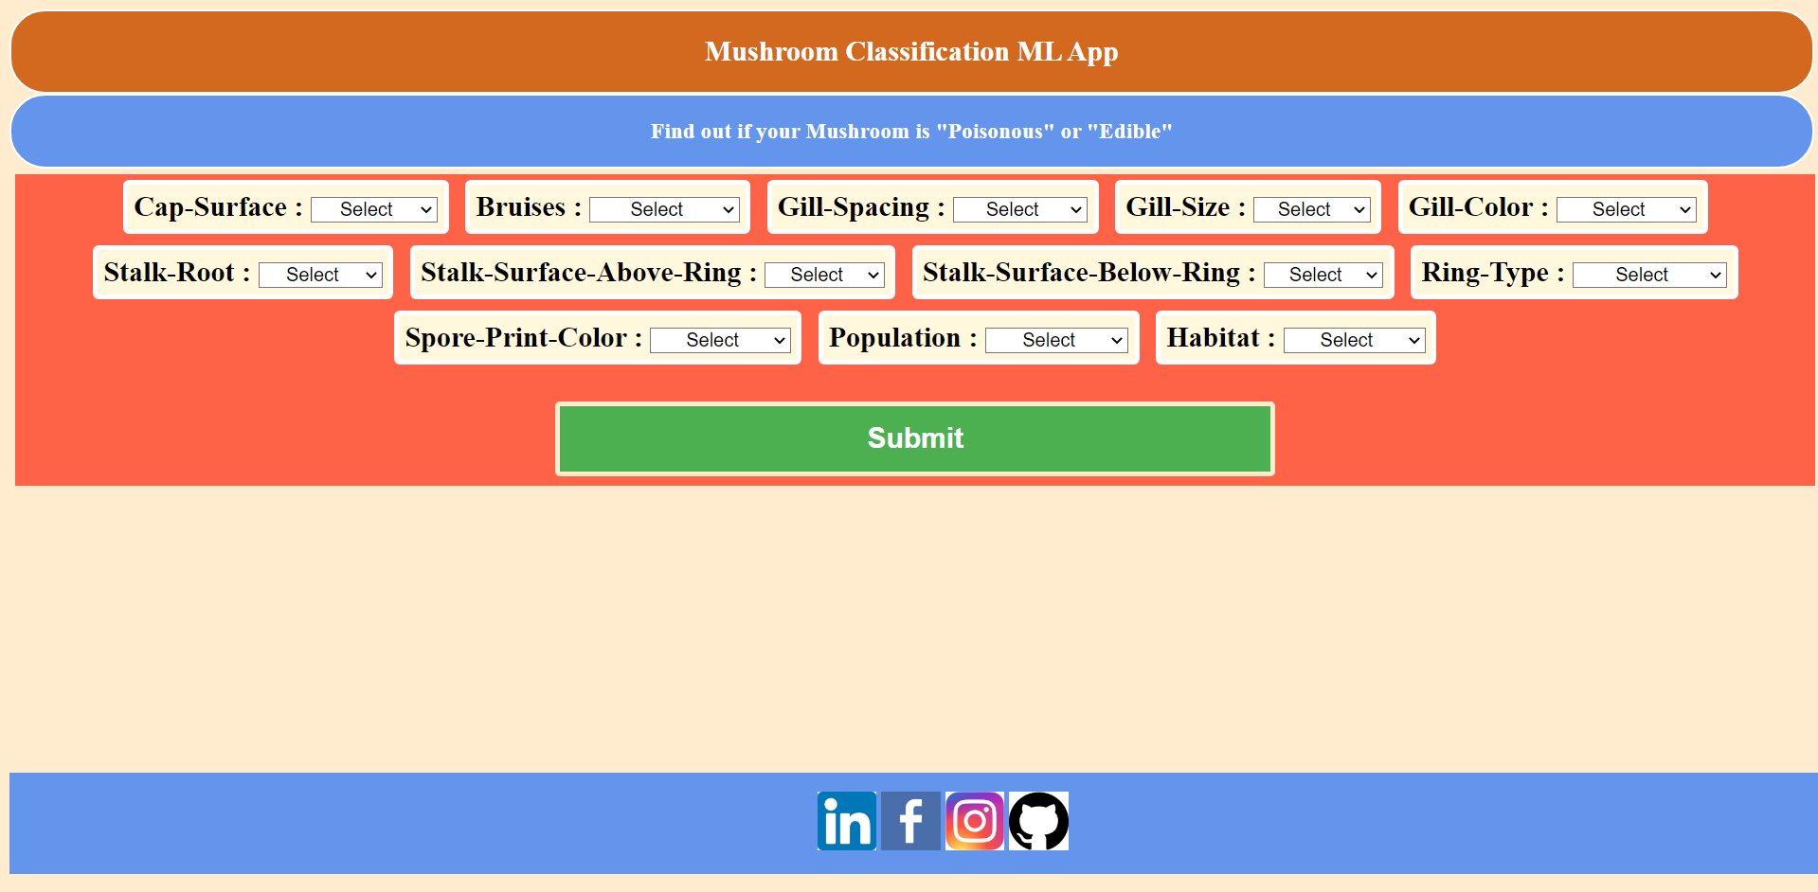

As you can see, there are total of 12 input fields (drop downs) you need to select based on the characteristics of the mushroom to find out if it’s edible or poisonous. There is a “Submit” button which redirect you the results page which will tell if the mushroom is poisonous or edible.

Also, at the bottom of the page you will find links to my LinkedIn, Facebook, Instagram and GitHub accounts.

* 1. **How to use?**

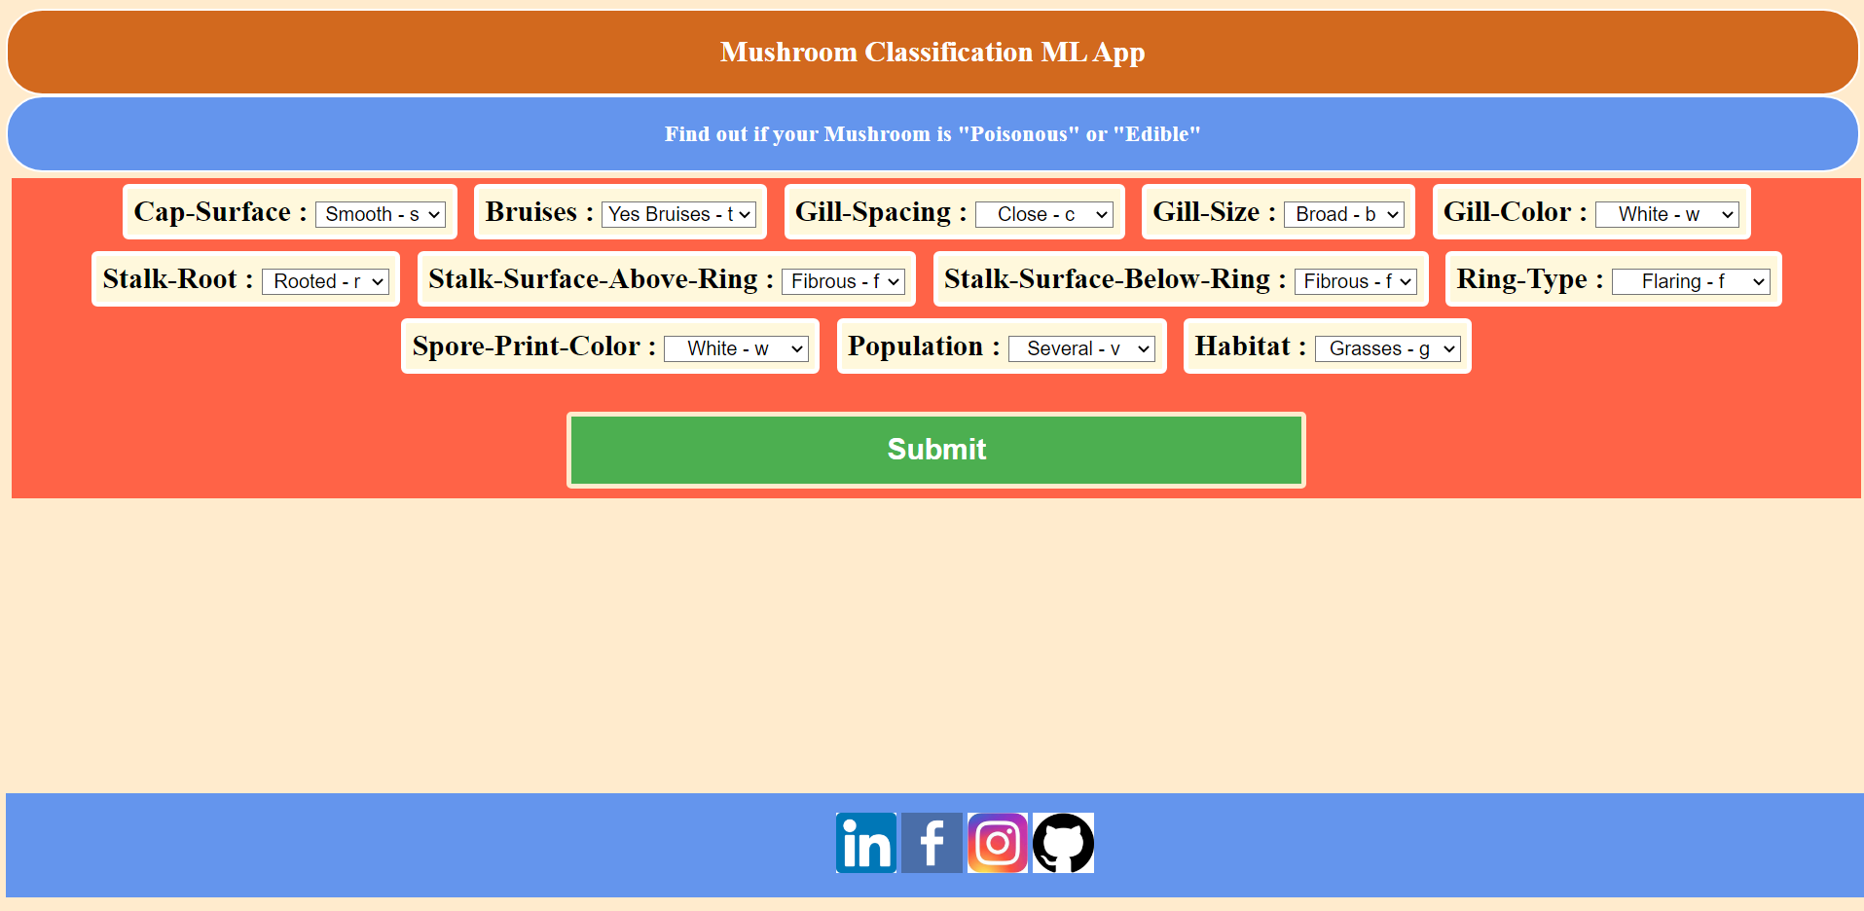

As you can see in the above picture you need to select the characteristics of the mushroom using the drop downs provided for each input fields. For above example I have selected:

* Cap-Surface: Smooth – s
* Bruises: Yes Bruises – t
* Gill-Spacing: Close – c
* Gill-Size: Broad – b
* Gill-Color: White – w
* Stalk-Root: Rooted – r
* Stalk-Surface-Above-Ring: Fibrous – f
* Stalk-Surface-Below-Ring: Fibrous – f
* Ring-Type: Flaring – f
* Spore-Print-Color: White – w
* Population: Several – v
* Habitat: Grasses – g

After selecting all the input fields, you just need to click on “Submit” button and it will take you to the results page.

**1.3 Results Page**

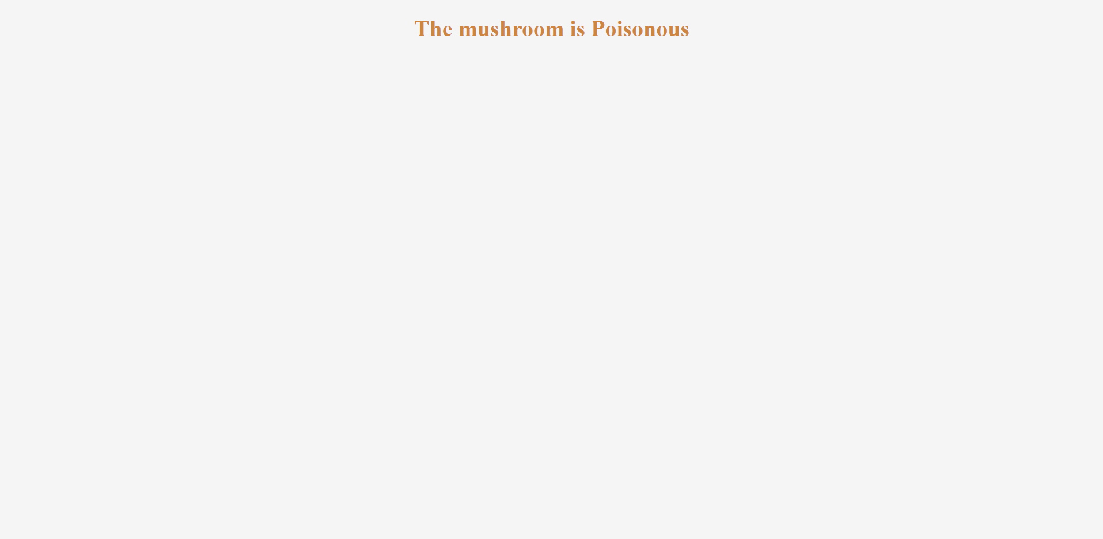

As you can see that based on the inputs that are selected, the given mushroom is Poisonous.

**2. Sample Cases:**

Here I am going to show you the both outputs i.e., Poisonous and Edible using input fields.

**2.1 Poisonous Mushroom Example**





**2.2 Edible Mushroom Example**

